SUBJECT ACCESS REQUEST FORM

(GDPR)

Contact Details (in block capitals):

Name
Address
Eircode
Contact Phone Number.
Contact Email.
Any additional identifier that may assist(e.g. MPRN)
Time Frame, from – to: (If relevant.)
Nature of Data Required.

Are you the Data Subject?
I am the Data Subject and enclose evidence of my identity.
E.g. photocopy of driving licence, birth certificate, passport etc. *

I am not the Data Subject, but I am acting on their behalf as their personal representative.
I have written authority, which I enclose and evidence of their identity. *

* Evidence will not be retained or filed once the request is complete it will be destroyed.
Do not enclose original documents.

I declare that all the details I have provided in this Form are true and complete to the best of my knowledge.

Signature of Requester: ____________________________ Date: _________________________________

Please return the completed Form by post to:
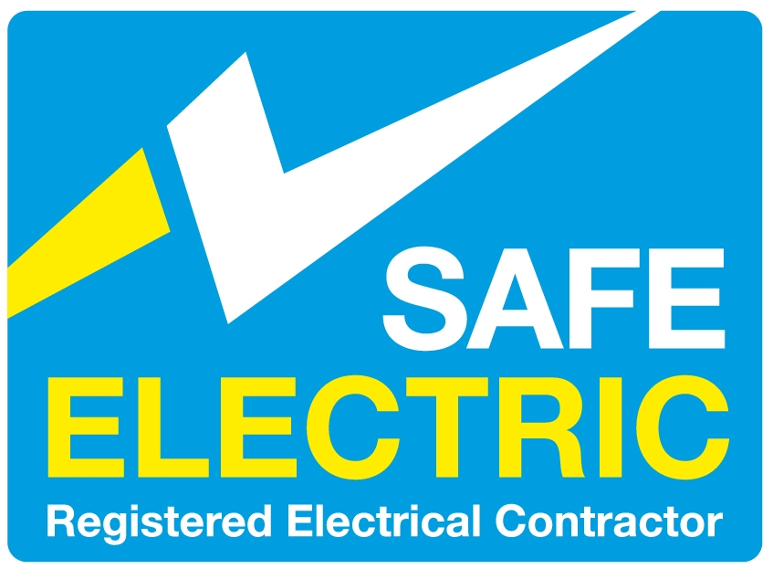
RECI.
Unit 9,
KCR Industrial Estate,
Ravensdale Park,
Kimmage,
Dublin 12.
Or by e-mail to:
dpo@reci.ie

* In order to respond to your request for personal data, you will need to provide us with adequate Proof of Identity.

Further information on Data Protection:
- The website of the Data Protection Commissioner – www.dataprotection.ie or
- Make contact with the Office of the Data Protection Commissioner by phone on Tel. +353 57 8684800 or by email at: info@dataprotection.ie.

